# IDEC Logo 9-29-05 med

# For Immediate Release

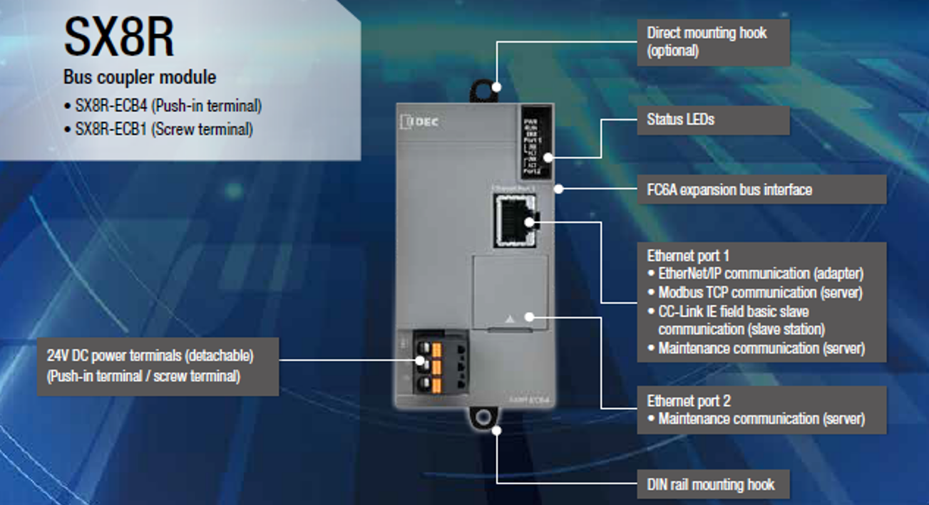

**IDEC “Bus Coupler” module brings simple connectivity for remote I/O systems**

***The compact SX8R Bus Coupler allows easy and affordable solutions for remote I/O systems. The coupler connects to a host system using major industrial networks, such as EtherNet/IP, Modbus TCP, and CC-Link, then allows the use of the IDEC FC6A expansion cards within a remote I/O structure.***

IDEC announces the new SX8R Bus Coupler module, which empowers users to easily deploy I/O modules throughout equipment and systems. This supports the industry design trend of using smaller, decentralized control panels to simplify installations and reduce wiring complexity, resulting in overall cost efficiency.

The IDEC SX8R Bus Coupler is an ideal way to design distributed remote I/O systems, or to expand the I/O count for controllers with limited base unit I/O points. For example, the SX8R works natively with IDEC PLC FC6A expansion I/O modules, which are available in over 40 models including a variety of digital and analog signal types. Each SX8R supports up to 7 I/O modules on the base unit, and up to 8 additional modules with the use of an expansion power supply, for a total of up to 15 I/O modules. A single SX8R can therefore support up to 480 discrete points (input and/or output), 120 analog inputs, and/or 60 analog outputs, depending on the configuration. The maximum number of SX8R nodes possible on a network is dependent on the host unit and the protocol - for instance, this means 255 nodes for Modbus TCP, 32 nodes for EtherNet/IP when using an IDEC FC6A Plus PLC, and 16 or 8 nodes for CC-Link when using specific Mitsubishi PLC models.

**Universal compatibility**

Engineered for reliability and performance, the SX8R Bus Coupler module supports major open networks, including EtherNet/IP, Modbus TCP, and CC-Link IE Field Basic, ensuring seamless integration with existing systems. This means the SX8R works well with a current setup without the need to replace other PLC makes/models, if the host device supports these major open networks. Whether upgrading existing systems or building new installations, the SX8R provides the connectivity and flexibility users need.

The SX8R features one Ethernet port for the uplink connection to the host network, and a second local Ethernet port for configuration purposes. Unlike some other bus couplers, the SX8R supports multiple protocols simultaneously.

**Compact and convenient form factor**

A compact form factor and direct or DIN rail mounting ensures the SX8R consumes minimal installation space, and the I/O modules and the expansion power supply simply click together to save installation time. The 24V DC power connector block is detachable & uses the latest push-in terminal technology for speed and durability. With a wide operating temperature range of -25 to +65 C, the SX8R is suitable for installation in the most challenging environments, and it is backed by a three-year warranty.

Free and easy-to-use PC-based SX8R Configurator software provides a convenient way for users to make operational settings, manage project files, perform system software updates, and monitor I/O and bus coupler status. User-friendly navigation and drag-and-drop functionality aids configuration, and settings can readily be copied and re-used on projects to reduce development time and effort. Status LEDs on the SX8R, and self-diagnostics available through the SX8R Configurator software, guides users so they can rapidly detect and correct any errors.

**Reliability and performance**

Remote I/O systems enhance efficiency and reliability in factory automation design. For small to medium-sized applications in industries such as water treatment, environmental control, material handling, food production, packaging, machine tools, agriculture, oil and gas, and many more, the IDEC SX8R Bus Coupler offers a powerful way to integrate trusted I/O hardware with host systems using standard industrial Ethernet.

As with all its products, IDEC offers free tech support for the SX8R Bus Coupler, with no service or support contract required. For complete specifications or additional information, please contact IDEC at eu.support@idec.com or visit us online at <https://lp.idec.com/SX8R> .

###

**About IDEC: *IDEC Corporation is a global supplier that has provided innovative and reliable industrial automation and control products since 1945. Covering a broad range of market needs, these feature-rich and value-driven products include PLCs, human machine interfaces (HMIs), safety products and other industrial automation components. By delivering world-class products backed by personalized service and highly-rated technical support, IDEC enables design engineers to create lean, cost-effective and safe solutions to optimize their automation applications. IDEC are one of the world's leading manufacturers of operator interface panels and related components, IDEC continues to enhance our customers’ ability to create high-quality solutions. For additional information, visit eu.idec.com***

For more information, please contact:

Steve Schiller

IDEC EMEA Business Unit Manager

[Steve.Schiller@apem.com](mailto:Steve.Schiller@apem.com)